

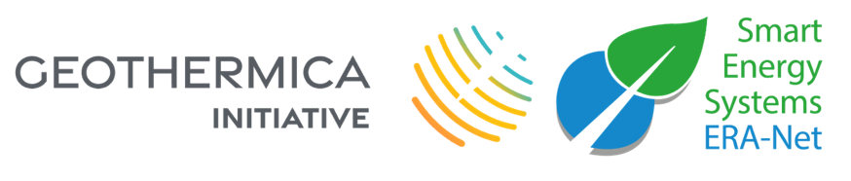

Template for final report
Final report template

Monitoring guidelines
Joint Call 2021
This template must be used to request approval of changes to the project. You should upload this to the Expera online platform and email this form to the Joint Call Secretariat, the National Contact Point in the country of the Country Coordinator, and other relevant Joint Call National Contacts Points. National procedures for the final report remain in full force and must be adhered to under all circumstances.

Identification of the project and change request
Project title
Project ID
Coordinator
Project website
Date

Participants
Organisation | Main contact(s) | E-mail(s) | Phone
[Coordinator]
[All other participants]

Short description of activities and final results
Describe the activities and final results on the work package and overall level, limited to 3 pages per work package. Explain any deviations from the proposal or the work plan. Include references to relevant publications, preferentially including hyperlinks.
Present an overview of financial results as well, per partner and per work package.

Project impact
Comment on the impact of the project, discussing the items below, if relevant for the project. Include a discussion of relevant market and policy developments and their potential impact.
- Demonstrating geothermal energy as a secure, sustainable, competitive and affordable energy source for Europe
- Demonstrating the significant role of geothermal energy within the energy system through novel concepts
- Strengthening the competitiveness and growth of European companies

Collaboration and coordination within the Consortium
Describe the collaboration and coordination within the Consortium. Comment on the effectiveness of management structures and governance procedures. Add a special focus on the added value of European trans-national collaboration on geothermal energy.

Dissemination activities (including list of publications where applicable)
List published project progress/outcomes such as brochures, media coverage, publications, patents, presentations, etc. and make sure that these will be available through the project website as well.

